Greetings,

I am pleased to share the outcome of the process our team has put in place to model available Fetch Reward’s data and ensure that our business leaders are accessing real-time data that will assist them in better serving our platform’s users and brand partners.

The following preliminary analysis and product and system recommendations are informed by our initial data modeling of the receipts, brands, and users data schemas as well as some findings addressing some of our leaders’ predetermined questions.

**Spending and Transaction Share for Top 5 Brands:**

The bulk of our analysis focused on exploring on two questions: 1) Which brand/s had the most *spend* among users who were created within the past 6 months. 2) Which brand/s had the most *transactions* (items purchased)among users who were created within the past 6 months.

Based on the two figures below, the main takeaways are that:

* Between Ben and Jerrys, Pepsi, Folgers, Kellogg’s, and Bigelow, these brands makeup approximately 7.3% of the total spending incurred by our recently created users.
* Between Ben and Jerrys, Pepsi, Dole, Folgers, and Knorr, these brands makeup 8.2% of the total transactions made among recently created users.

Spending share of the top five brands among users who were created within the past 6 months

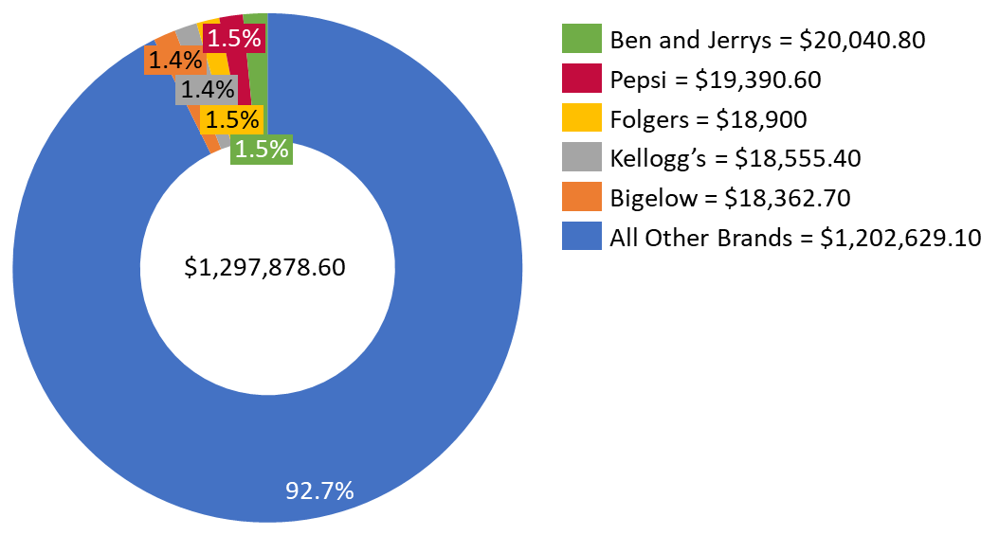

Transaction share of the top five brands among users who were created within the past 6 months

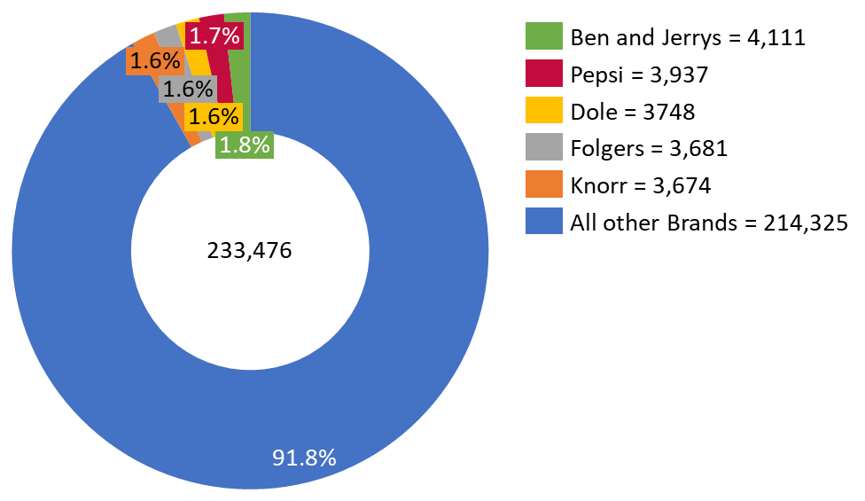

**Product Recommendation:**

Based on the above preliminary analysis, our recommendation is that we further review the behavior patterns of recently created users who buy at these brands and provide targeted reward incentives for other brands users may be likely to purchase from based on their initial purchase of these top 5 brands. This strategy will not only reward users for their brand loyalty but compel them to shop and scan their receipts for co-purchased items. This in turn will benefit the rest of our brand partners who are ultimately wanting to boost their sales.

**System Recommendation:**

In an effort to provide collegial transparency, we do want to discuss next steps regarding the current state of our data system and address what remaining work needs to be done to better improve our workflow. Per our internal analysis, we found three main issues that impede us from establishing a proper relational database model:

1. Data extracted from the API is not formatted properly which causes delays in database modeling.
2. There is a good number of fields, specifically within the receipts data schema, that are deeply nested and that greatly change the structure of our model once flatten. In fact, at present, the receipts table mirrors more of an items table given that we need to extract brands data for each individual item. This makes it quite difficult to establish a primary key.
3. There is a weak relationship between the receipts and brands data schemas given that there is a lot of missing data or data that has not been vetted for quality assurance. At present, no link between a foreign key and a unique column could be established between these two tables.

Of course, this list is not exhaustive, however, as a team we believe these are the most pressing concerns that we should address to create a database that is efficient, accurate, and integral. If you can facilitate a follow up meeting with the data engineering team, to get a better understanding of 1) how receipts are processed? 2) how we capture brand information from our partners? 3) how is data extracted from the API? – that would be a great first step in better understanding our internal data pipelines.

Again, thank you for the participatory process and the thoughtful input of all stakeholders that shaped these insights. Those collaborative practices will aid Fetch Rewards in better serving our users and brand partners and becoming a household name.

Best,

Selvyn